1 Engines

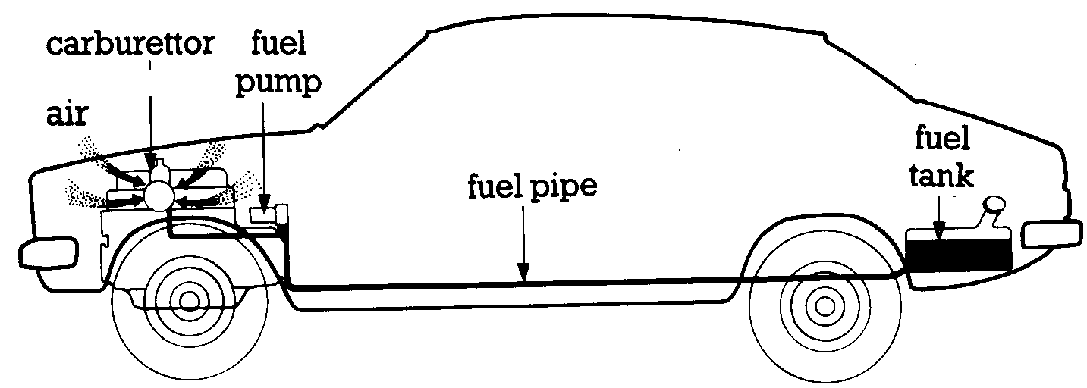

An engine produces power by burning air and fuel. The fuel is stored in a fuel tank. (This is usually at the back of the car.) The fuel tank is connected to a fuel pipe. The fuel pipe carries the fuel to a fuel pump. The fuel pump is connected to the carburettor. The fuel pump pumps the fuel into the carburettor. In the carburettor the fuel is mixed with air. The fuel and air are drawn into the engine. In the engine the fuel and air are burned to produce power.

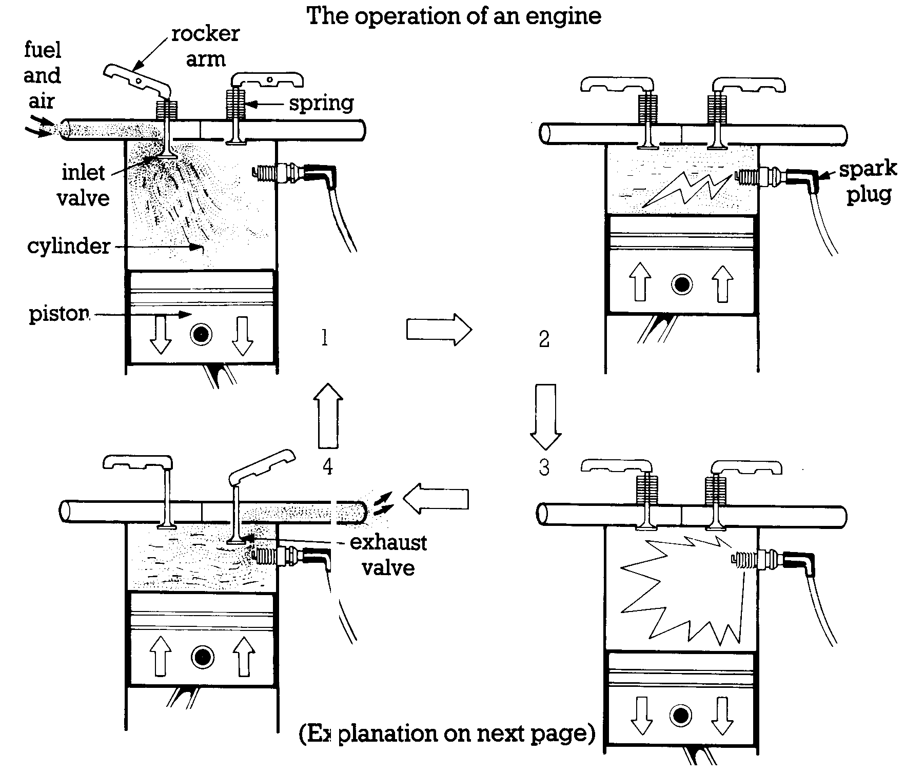

An engine produces power by burning fuel and air. The fuel and air are mixed in the carburettor. The inlet valve is opened by a rocker arm. The fuel and air are drawn into the cylinder by the piston (Diagram 1). Then they are compressed by the piston. The inlet valve is closed by a spring. The fuel and air are then ignited by the spark plug (Diagram 2). They burn and expand very quickly and push the piston down (Diagram 3). The exhaust valve is now opened by a rocker arm. The burned fuel and air are expelled from the cylinder by the piston (Diagram 4).

Make seven sentences from this table:

 |  |  | pushed down |  | the piston.
 | piston |  | ignited |  | a rocker arm.
 | fuel and air | is | closed | by | a spring.
The
 | exhaust valve | are | opened |  | the spark plug.
 | inlet valve |  | compressed |  | the fuel and air.

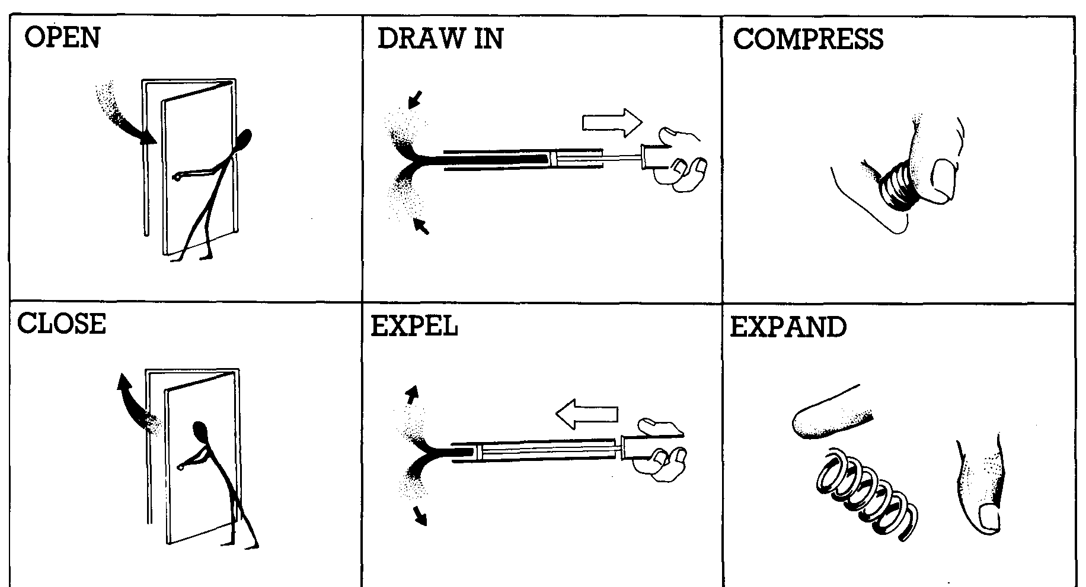

2 History of engines

In 1870 a German engineer called Nikolaus Otto designed the first internal combustion engine. The first motor car which used Otto's engine was made in 1875 and Daimler and Benz started selling cars with petrol engines in 1885. Engineers in many countries tried to invent other kinds of engine. Otto's engine produced power by burning fuel and air. A mixture of petrol and air was compressed and then exploded by a spark. This explosion drove a piston in the cylinder.

In 1892, however, another German engineer, Rudolph Diesel, created a different type of engine. In the Diesel engine the temperature of the air inside the cylinder was raised to a higher point than in Otto's engine by greater compression. When a fine spray of oil was injected into the cylinder an explosion was caused without a spark. Diesel's first engine exploded and nearly killed him, but in 1897 he successfully designed and produced his engine. Diesel's engines were heavier than petrol engines but they had no electrical system or carburettor and they ran on heavier oil.

Dieselelectric engines, which are now used on some railway systems, are diesel engines which turn an electric generator. The generator supplies power to an electric motor. Electric motors do not have a gearbox and, combined with a diesel motor, this is very efficient.

3 Metals in use

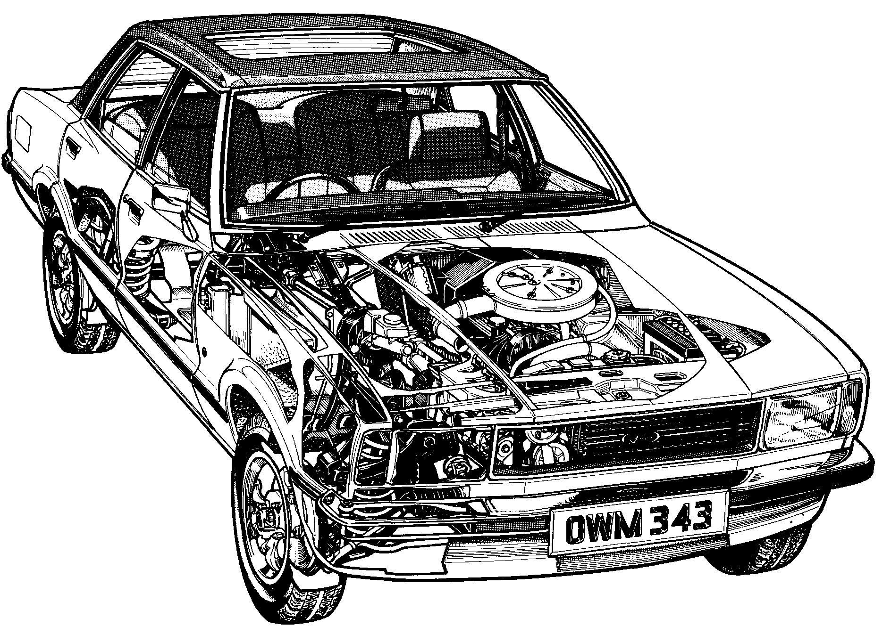
Metals, metals everywhere! Let's just have a look at what this car consists of. Say it weighs in all about 1,000 kg. Of that 1,000 kg there's 140 kg of cast iron for the cylinder block, gearbox, etc. Then you've got 15 kg of zinc in things like the door handles and carburettor, 10 kg of copper for pipes in the radiator and cables, 15 kg of aluminium, mostly in the pistons, and 5 kg of lead in the battery. Then finally, there is an enormous 700 kg of steel. A further 100 or so kilograms of non-metals - glass, rubber and plastic - make up the total. But is it all really necessary? All these metals and some of them are quite rare - are being used up at a frightening speed. Take this bumper. AB you can see, it's shiny. That's because it's covered in chromium. But it's not made of chromium. It's made of steel. The chromium is just there to make it look nice. Now that would be bad enough. But, you see, chromium won't stick to steel, but it will stick to nickel; so under the chromium there is a layer of nickel. But nickel won't stick to steel either. Copper will, however; so there has to be a layer of copper to bind the nickel and the steel. So, that's what is on the bumper: a sandwich of three rare metals. And what happens when it gets scratched or dented? We probably just throw it away.

Exercise 1
Use these words and expressions to replace expressions of similar meaning in the INPUT.

in total; huge; additional; too quickly; about 100 kilograms; to stick together.

Exercise 2
Look at the text below.

The modern world wastes huge amounts of metal. We've looked at all the different metals used in a car. But it isn't just in the car itself that we waste metal. Think of all the metal used in making the car. The machines in the car factories are all made of metal.
Now this would not be so bad, if we got all these metals back. But we don't. Every day in Britain, 4000 cars are scrapped. Yet only 3000 of those cars go for recycling. The other 1000 are lost. So every year from those 1000 cars we lose 190,000 tons of steel, 2000 tons of copper. We lose forever 3000 tons of zinc and the same amount of aluminium; 1000 tons of lead go out of circulation. And that is just for Britain. Multiply these figures to get the amounts for the world and you will see how big the problem is. The supplies of metals are limited. One day we won't have enough Perhaps we can find alternative energy sources from the sun and the wind; but alternatives to metals - where will we find them?

What are the possible solutions to the above described problem?

Possible solutions are:
- Recycling metals i e. when a car is no longer usable, it could be stripped down to separate out the different metals it contains, and each of these could be melted down and used to make other goods;
- Not using metals wastefully e.g. in car bumpers. The steel in the bumper could be covered with a thin coating of plastic instead.
- Not using metals at all, where possible. The whole bumper could be made of a material like plastic.
- Damaged parts should be repaired, rather than thrown away, whenever possible. Also, if only one part of a mechanism is broken, it should be possible to buy a replacement for only the part that is broken, rather than having to buy a whole new unit.

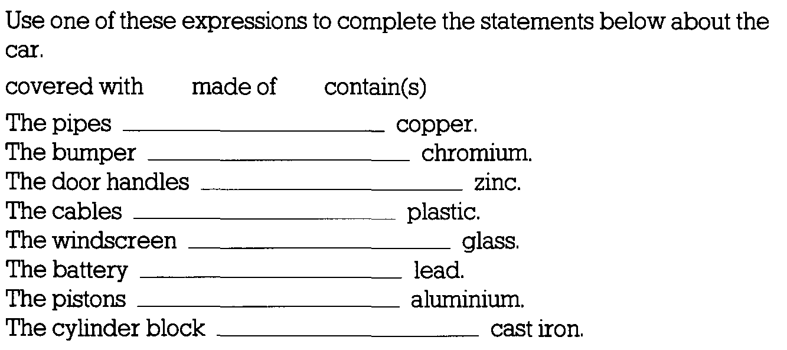
Exercise:

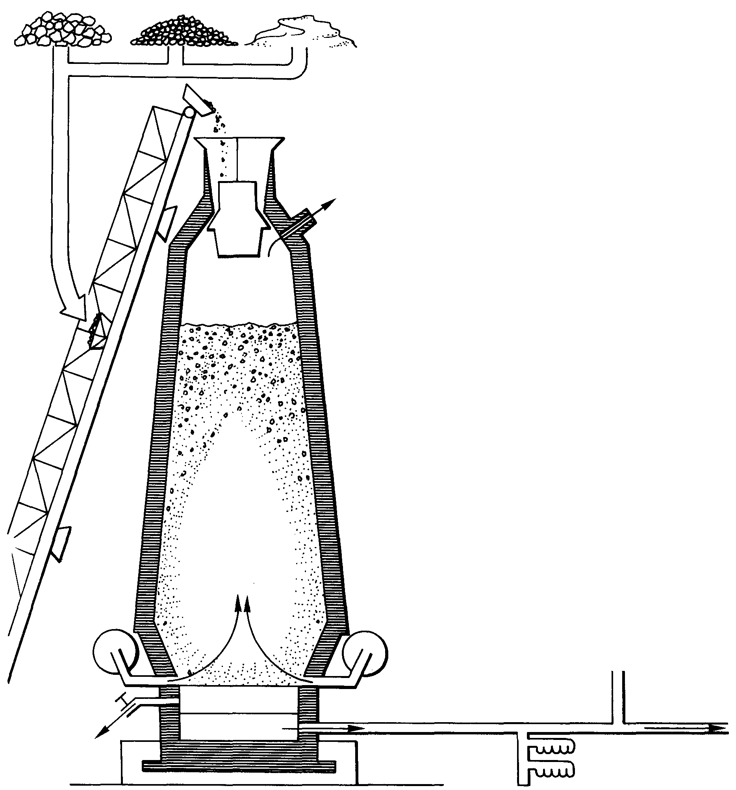
4 Extracting metals

Use the picture to help you understand the text.

Separating a metal from the other minerals in the ore is known as extraction or smelting. Most metals are smelted using heat, although some, e.g. aluminium, are extracted by an electrical process.

Iron is smelted in a tall metal tower, called a blast furnace. The tower is lined with fire-brick and is normally kept burning continuously for several years. Four ingredients are needed: iron ore, coke, limestone and hot air.
A mixture of crushed iron ore, coke and limestone is taken in a skip up a ramp and fed into the top of the furnace. Hot air is blasted into the base of the fire to produce a very high temperature (l,800°C*).

The smelting process produces three substances: gas, molten ore and slag, The gases escape through an outlet at the top of the furnace, The liquid iron settles at the bottom of the tower. The slag, which consists of the molten limestone and all the impurities it has absorbed, also runs down to the bottom; but, since it is lighter than the liquid iron, it floats on top of it. Periodically, the iron and the slag are drained off through valves at the bottom of the tower.
When the iron leaves the furnace, it still contains some impurities, particularly carbon. Some of the molten iron is run off into large molds* called pigs, where it is cooled ready for further refining and processing into cast iron at a later stage. The remainder is taken away in its molten state for further processing into wrought iron or steel.

Exercise
Find words and expressions from the INPUT, which mean the same as:

forced under high pressure
the bottom
to take out
melted
is called
unwanted substances
covered on the inside
at intervals
broken into small pieces
especially

Exercise
Iron is smelted in a tall tower called a blast furnace.
Find other examples of the passive in the INPUT. Why is it used so much? Use these cues to make sentences describing the process of making iron.

hot air/blast/bottom/tower
take away/process/ steel/wrought iron
4 ingredients/need/iron ore, coke, limestone, hot air
iron/extract/heat
cast/shapes
molten iron/drain off
mixture/feed/top/furnace
iron ore/crush/mix! coke/limestone
iron/smelt/tall tower/blast furnace

The Discovery of Metals

Life as we know it today would be impossible without metals. Until he discovered how to make things with metal, man had only stone and wood as raw materials. The first metal that primitive man used was copper - a pure or base metal. This was around 5000 B. C. in the Middle East. Copper has the advantage of being very easy to extract from rock, but its use is limited, because it is fairly soft.
About 1500 B. C. it was discovered that if copper was mixed with tin - another soft metal- the resulting alloy was very much harder than either of them This alloy is called bronze.
The softer metals - copper, tin, lead, gold - were the first metals to be used, because they needed less heat to smelt them It was not till 600 B. C. that the Greeks learnt how to extract the hard metal, iron, from its ore. Even then, only small amounts could be produced, because there was not enough charcoal available. It was not until the 18th century that an Englishman, Abraham Darby, discovered that coke could be used instead of charcoal. This made it possible to produce the vast amounts of iron and steel that we use today.

